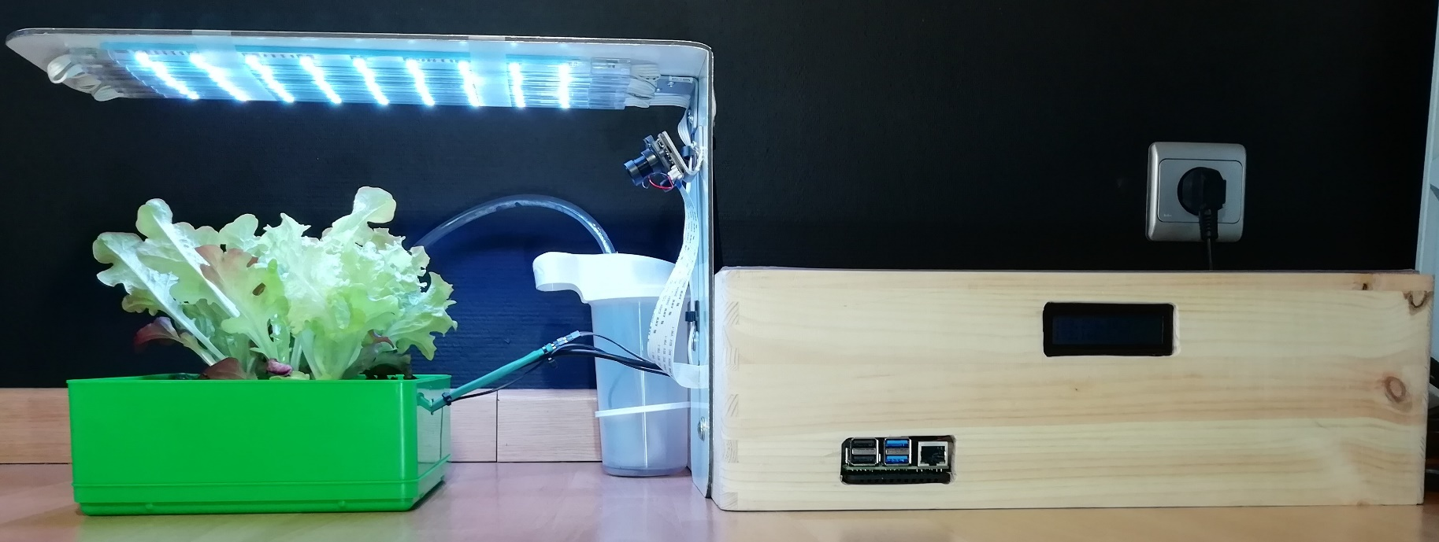


Smart Plant Controller
Maximum Yield
Minimum Effort
Made By
Joren vanGoethem – 1MCT

